The following information may be useful. The symbols have their usual meaning.

*Maklumat berikut mungkin berfaedah. Simbol-simbol mempunyai makna yang biasa.*

1. a = 16. Power, P =

2. v2 = u2  + 2as *Kuasa, P* =

3. s = ut + ½ at2 17. V = IR

4. Momentum = mv 18. Power, P = IV

*Kuasa*

5. F = ma 19.

6. Kinetic energ = ½ mv2 20. Efficiency = $\frac{I_{s}V_{s}}{I_{p}V_{p}} x 100$

*Tenaga kinetik*  *Kecekapan*

7. Gravitational potential energy = mgh 21. $\frac{1}{f}= \frac{1}{u}+ \frac{1}{v}$

*Tenaga keupayaan graviti*

8. Elastic potential energy = ½ Fx 22. n = $\frac{\sin{i}}{\sin{r}}$

*Tenaga keupayaan kenyal*

9. ρ = 23. n =

10. Pressure, P = hρg *n =*

*Tekanan*

11. Pressure, P = 24. λ =

*Tekanan*

25. Q= It

12. Heat, Q = mcθ

*Haba* 26. E = I (R + r)

13. = Constant (*pemalar)* 27. eV = ½ mv2

14. E = m c2 28. g = 10 ms-2

15. v = f λ

1. Which of the following is a unit for a derived quantity?

*Antara yang berikut, manakah unit bagi kuantiti terbitan*?

1. Watt, W
2. Meter, m
3. Ampere, A
4. Kilogram, kg
5. Diagram 1 shows a micrometer screw gauge used to measure the thickness of 100 pieces of paper.

*Rajah* 1 *menunjukkan tolok skru mikrometer yang digunakan untuk mengukur ketebalan* 100 *helai kertas.*

0

1

2

3

4

35

30

25

Diagram 1

*Rajah* 1

What is the thickness of one piece of paper in mm?

*Apakah ketebalan sehelai kertas dalam* mm?

1. 0.0432
2. 0.0438
3. 0.0482
4. 0.0488
5. Diagram 2 shows a boy standing on the platform of a train station watching a train. The train starts from rest and moves with an acceleration of 0.2 ms–2. The boy observes that the train takes 24 s to move past him.

*Rajah* 2 *menunjukkan seorang budak lelaki berdiri di atas platform di sebuah stesen kereta api dan sedang memerhati sebuah kereta api. Kereta api itu mula bergerak dari keadaan rehat dan bergerak dengan pecutan* 0.2 ms–2. *Budak lelaki itu mendapati bahawa kereta api itu mengambil masa* 24 s *untuk bergerak melaluinya*.



Diagram 2

*Rajah* 2

What is the length of the train?

*Berapakah panjang kereta api itu*?

* 1. 48.0 m
  2. 57.6 m
  3. 115.2 m
  4. 120.0 m

1. Diagram 3 shows a pillion rider moving backwards when the motorcycle accelerates.

Rajah 3 menunjukkan keadaan pembonceng motosikal yang bergerak ke belakang apabila motosikal mula memecut.

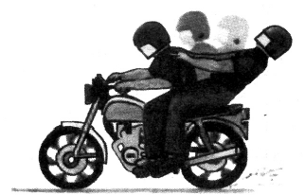

Diagram 3

Rajah 3

The backwards movement of the pillion rider can be explained by

Pergerakan pembonceng itu ke belakang boleh diterangkan oleh

1. the concept of inertia

konsep inersia

1. the concept of equilibrium of forces

konsep keseimbangan daya

1. principle of conservation of momentum

prinsip keabadian momentum

1. principle of conservation of energy

prinsip keabadian tenaga

1. Diagram 4 shows trolley P of mass 1.1 kg moving to the right with a velocity of 15 m s-1. It collides head-on with a trolley Q of mass 1.0 kg which is initially at rest. The two trolleys stuck together after the collision.

*Rajah* 4 *menunjukkan troli* P *dengan jisim* 1.1 kg *bergerak ke kanan dengan kelajuan* 15 m s-1. *Troli tersebut berlanggar dengan troli* Q *berjisim* 1.0 kg *yang tidak bergerak. Kedua-dua troli tersebut melekat bersama selepas perlanggaran tersebut.*

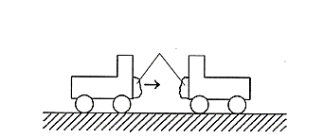

Diagram 4

*Rajah* 4

*u* = 15 m s-1

plasticine

*plastisin*

*u* = 0

**Q**

**P**

What is the velocity of the trolleys after the collision?

*Apakah halaju bersama troli-troli tersebut selepas perlanggaran*?

1. 4.12 m s-1
2. 5.93 m s-1
3. 6.14 m s-1
4. 7.86 m s-1
5. A ball of mass 0.5 kg is being kicked by a force of 10 N. If the force is exerted in 0.2 s, what is the impulse experienced by the ball?

*Sebiji bola berjisism* 0.5 kg *ditendang dengan daya* 10 N.  *Jika daya dikenakan dalam masa* 0.2 s*, berapakah impuls yang dialami oleh bola*?

* 1. 2.0 N s
  2. 10.2 N s
  3. 30.0 N s
  4. 50.0 N s

1. Why are the front and rear sections of a car designed to crumple easily?

Mengapakah bahagian hadapan dan bahagian belakang kereta direka bentuk supaya mudah remuk?

1. To decrease impulse

Untuk mengurangkan impuls

1. To decrease momentum

Untuk mengurangkan momentum

1. To increase friction

Untuk menambahkan geseran

1. To increase impact time

Untuk menambahkan masa hentaman

1. Diagram 5 shows a stroboscopic photograph of a ball falling towards the ground.

*Rajah* 5 *menunjukkan gambar foto stroboskop sebiji bola yang sedang jatuh ke tanah.*

Diagram 5

*Rajah* 5

Which statement describes the motion of the ball?

*Pernyataan manakah menerangkan gerakan bola itu*?

1. It falls with constant velocity

*Ia jatuh dengan halaju malar*

1. It falls with decreasing velocity

*Ia jatuh dengan halaju berkurangan*

1. It falls with constant acceleration

*Ia jatuh dengan pecutan malar*

1. It falls with increasing acceleration

*Ia jatuh dengan pecutan bertambah*

1. Diagram 6 shows the horizontal forces acting on the motorcycle when it is accelerating.

*Rajah* 6 *menunjukkan daya-daya mengufuk yang bertindak ke atas motosikal yang sedang memecut*.

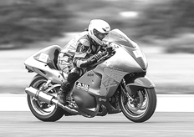

Forward thrust, F

*Daya tujah*, F

Air resistance, R

*Rintangan udara*,R

Friction, G

*Geseran*,G

Diagram 6

*Rajah* 6

Which relationship is **correct**?

*Hubungan yang manakah* ***benar***?

* 1. R + F = G
  2. R + G > F
  3. R + G < F
  4. R + G = F

1. Diagram 7 shows a horse is pulling a rope to lift a load of 40 kg through a vertical height of 4 m in 5 s.

*Rajah* 7 *menunjukkan seekor kuda menarik tali untuk mengangkat beban berjisim* 40 kg *setinggi* 4 m *dalam masa* 5 s.

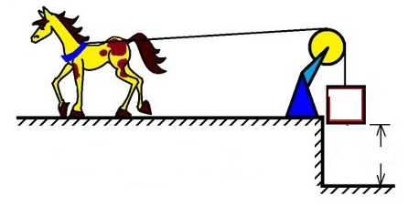

4 m

Diagram 7

*Rajah* 7

What is the power of the horse to lift the box?

*Berapakah kuasa kuda untuk mengangkat kotak itu*?

* 1. 50 W
  2. 320 W
  3. 500 W
  4. 800 W

1. Diagram 8 shows the position of a metal ball at the compressed spring and after the spring is released.

*Rajah* 8 *menunjukkan kedudukan sebiji bebola logam dalam keadaan spring termampat dan setelah spring dilepaskan.*

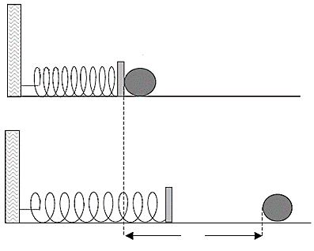

Diagram 8

*Rajah* 8

***x***

metal ball

*bola logam*

compressed spring

*spring dimampatkan*

spring released

*spring dilepaskan*

Distance *x* can be increased by using

*Jarak x boleh ditambah dengan menggunakan*

* 1. a softer spring

*spring yang lebih lembut*

* 1. a longer spring

*spring yang lebih panjang*

* 1. a spring with bigger diameter

*spring berdiameter lebih besar*

* 1. two identical springs connected in parallel

*dua spring yang sama disusun secara selari*

1. Two sharp nails and two blunt nails are held on a piece of wood. Each nail is hit with the same hammer with the same force. When it is hit, which nail causes the greatest pressure on the wood?

*Dua paku yang tajam dan dua paku yang tumpul diletakkan di atas sekeping kayu. Setiap paku diketuk oleh penukul dengan daya yang sama. Apabila diketuk, paku yang manakah yang akan menyebabkan tekanan paling tinggi*?

|  |
| --- |
| **A**  **B**  hammer  *penukul*  sharp nail  *paku tajam* |

|  |
| --- |
| **C**  **D**  hammer  *penukul*  blunt nail  *paku tumpul* |

1. Diagram 9 shows the arrangement of an apparatus for an experiment.

*Rajah* 9 *menunjukkan susunan radas bagi satu eksperimen*.

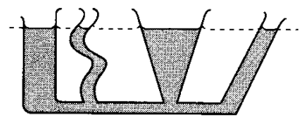

liquid

*cecair*

Diagram 9

*Rajah* 9

Which of the following conclusions is **correct**?

*Yang manakah antara kesimpulan berikut adalah* ***betul***?

1. Liquid pressure is caused by its weight acting on a surface

*Tekanan cecair disebabkan oleh beratnya yang bertindak ke atas permukaan*

1. Liquid pressure does not depend on the shape of the container

*Tekanan cecair tidak bergantung pada bentuk bekasnya*

1. Liquid pressure acts perpendicularly to its surface

*Tekanan cecair bertindak serenjang pada permukaannya*

1. Liquid pressure increases with depth

*Tekanan cecair bertambah dengan kedalaman*

1. Diagram 10 shows a U-tube manometer connected to a gas tank whose valve is then turned on.

*Rajah* 10 *menunjukkan satu tiub-*U *manometer disambungkan kepada satu tangki gas yang kemudian dibuka injapnya*.

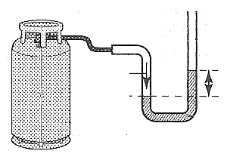

Diagram 10

*Rajah* 10

Gas

5 cm

Gas tank

*Tangki gas*

Mercury

*Merkuri*

Determine the pressure of the gas in the tank.

*Tentukan tekanan gas dalam silinder itu*.

[ Atmospheric pressure / *Tekanan Atmosfera* = 75 cm Hg ]

1. 5 cm Hg
2. 70 cm Hg
3. 75 cm Hg
4. 80 cm Hg
5. Which device application is based on the Pascal’s principle?

*Alat yang manakah berasaskan prinsip Pascal*?

* 1. Jet engine

*Enjin jet*

* 1. Hydrometer

*Hidrometer*

* 1. Hydraulic jack

*Jek hidraulik*

* 1. Hot air balloon

*Belon udara panas*

1. Diagram 11 shows the set of experiments and the results obtained by a student.

*Rajah* 11 *menunjukkan set eksperimen dan keputusan yang diperolehi oleh seorang murid*.

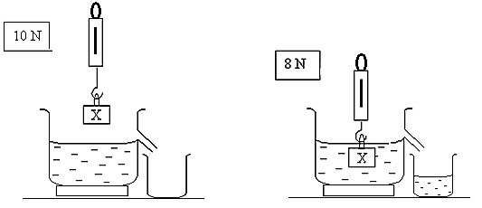

8 N

10 N

Diagram 11

*Rajah* 11

Based on the observations in Diagram 11, calculate the volume of block X.

[ Density of water = 1000 kg m – 3 and g = 10 m s – 2 ]

*Berdasarkan pemerhatian pada Rajah* 11, *hitung isipadu bagi blok* X.

*[ Ketumpatan air =* 1000 kg m – 3 *dan g =* 10 m s – 2 *]*

* 1. 1 x 10 – 4 m3
  2. 2 x 10 – 4 m3
  3. 4 x 10 – 4 m3
  4. 8 x 10 – 4 m3

|  |  |
| --- | --- |
| **17.** | Diagram 12 (a) shows the design of a piece of boomerang. Diagram 12 (b) shows the movement of the boomerang after being thrown into the air in circular motion.  *Rajah* 12 (a) *menunjukkan binaan sebilah boomerang. Rajah* 12(b) *menunjukkan apabila boomerang dibaling ke udara, ia bergerak dalam bentuk bulatan.*    Diagram 12 (a) Diagram 12 (b)  *Rajah* 12 (a) *Rajah* 12 (b)  The motion of the boomerang is due to  *Pergerakan boomerang itu adalah disebabkan oleh*  **A** Pascal’s principle  *Prinsip Pascal*  **B** Bernoulli’s principle  *Prinsip Bernoulli*  **C** Archimedes’ principle  *Prinsip Archimedes*  **D** The principle of conservation of energy  *Prinsip keabadian tenaga* |
| **18.** | Diagram 13 (a) shows water at temperature 30oC is poured into a glass filled with ice. Diagram 13 (b) shows the state of the liquid after the ice has melted.  *Rajah* 13 *(a) menunjukkan air pada suhu* 30oC *dituang ke dalam gelas berisi ais.*  *Rajah* 13 *(b) menunjukkan keadaan cecair itu selepas ais itu telah melebur*    Diagram 13  *Rajah* 13  Which of the following statements is **true**?  *Yang manakah antara pernyataan-pernyataan berikut adalah* ***benar***?  **A** Heat from water is absorbed by the ice  *Haba daripada air diserap oleh ais*  **B** The final temperature of liquid is more than 30oC  *Suhu akhir cecair adalah lebih daripada* 30oC  **C** Ice melted due to release of heat to the surroundings  *Ais melebur disebabkan oleh pembebasan haba ke persekitaran*  **D** Specific heat capacity is used to break up the bonding between the ice molecules  *Muatan haba tentu digunakan untuk memutuskan ikatan antara molekul-molekul*  *ais* |
| **19.** | On a hot, sunny day by the beach, the sand feels very hot while the sea water remains cool. Which concept best explains this occurrence?  *Pada suatu hari yang panas terik di tepi pantai, pasirnya sangat panas manakala air laut terasa sejuk. Konsep manakah paling sesuai untuk menerangkan kejadian tersebut?*  **A** Thermal equilibrium  *Keseimbangan terma*  **B** Thermal conductiviy  *Kekonduksian terma*  **C** Specific heat capacity  *Muatan haba tentu*  **D** Specific latent heat  *Haba pendam tentu* |
| **20.** | Diagram 14 shows a 5.0 kg metal cylinder with specific heat capacity of 450 J kg –1o C–1  is heated using a heater of power 1 kW. The heater is switched on for 10 s.  *Rajah* 14 *menunjukkan* 5.0 kg *silinder logam dengan muatan haba**tentu* 450 J kg –1 o C–1 *dipanaskan menggunakan pemanas berkuasa* 1 kW*. Pemanas dihidupkan selama* 10 *s.*    heater  *pemanas*  thermometer  *termometer*  metal cylinder  *silinder logam*  Diagram 14  *Rajah* 14  What is the rise in temperature of the cylinder?  *Berapakah kenaikan suhu silinder itu?*   |  |  |  |  | | --- | --- | --- | --- | | **A** | 0.23 oC | **B** | 0.44 oC | | **C** | 4.44 oC | **D** | 5.00 oC | |
| **21.** | Diagram 15 shows the pressure of a car tyre is 210 kPa at temperature 33°C.  *Rajah* 15 *menunjukkan tekanan pada tayar kereta adalah* 210kPa *pada suhu* 33°C*.*    Diagram 15  *Rajah* 15  After a long journey, the temperature of the tyre increased to 57°C. What is the new pressure? (Volume of the air in the tyre does not change)    *Selepas satu perjalanan yang jauh, suhu tayar itu meningkat kepada* 57°C*, berapakah tekanan yang baharu? (Isipadu udara di dalam tayar tidak berubah)*  **A** 121.6 kPa  **B** 194.7 kPa  **C** 226.5 kPa  **D** 362.7 kPa |
| **22.** | Diagram 16 shows an incident ray of light directed to a plane mirror, PQ with i = 50o . *Rajah* 16 *menunjukkan sinar cahaya menuju cermin satah* PQ *pada sudut* i *=* 50o *.*    Diagram 16  *Rajah* 16  What is the reflected angle of light ray when the plane mirror PQ is rotated 30o to P” Q”?  *Berapakah sudut pantulan cahaya itu apabila cermin satah* PQ *di putar sebanyak* 30o *ke kedudukan* P” Q”*?*  **A** 70o  **B** 30o  **C** 50o  **D** 20o |
| **23.** | Diagram 17 shows a path of light ray passing through a convex lens.  *Rajah* 17 *menunjukkan lintasan sinar cahaya yang melalui sebuah kanta cembung.*    Convex lens  *Kanta cembung*  **S**  **R**  **Q**  **P**  Incident ray  *Sinar tuju*  2F  F  F  Diagram 17  *Rajah* 17  Which refracted ray is **correct**?  *Sinar biasan manakah yang* ***betul****?*   |  |  |  |  | | --- | --- | --- | --- | | **A** | P | **B** | Q | | **C** | R | **D** | S | |
| **24.** | Diagram 18 shows a light ray, P is directed to the centre, O of semicircular glass block. Refractive index of the glass is 1.57.  *Rajah* 18 *menunjukkan satu sinar cahaya* P*, ditujukan kepada pusat,* O *satu bongkah*  *kaca semibulatan. Indeks biasan kaca itu adalah* 1.57*.*    420  O  Glass block  *Blok kaca*  Diagram 18  *Rajah* 18  At which direction **A, B, C** or **D** does the light propagate after point O?  *Arah manakah antara* **A, B, C***atau* **D** *sinar itu merambat selepas titik* O*?* |
| **25.** | Which of the following statement is **true** about the telescope?  *Antara pernyataan berikut manakah* ***betul*** *mengenai teleskop*?  **A** The objective lens and eyepiece are concave lens  *Kanta objektif dan kanta mata adalah kanta cekung*  **B** Power of objective lens < power of eyepiece  *Kuasa kanta objektif < kuasa kanta mata*  **C** Normal adjustment > focal length of eyepiece + focal length of objective lens  *Pelarasan normal > jarak fokus kanta mata + jarak fokus kanta objektif*  **D** Normal adjustment < focal length of eyepiece + focal length of objective lens  *Pelarasan normal < jarak fokus kanta mata + jarak fokus kanta objekif* |
| **26.** | Diagram 19 shows a displacement-distance graph of a wave.  *Rajah* 22 *menunjukkan graf sesaran-jarak bagi satu gelombang.*    Diagram 19  *Rajah* 19   |  |  | | --- | --- | | What is the amplitude of the wave?  *Apakah amplitud gelombang?* | | | **A** | 2 cm | | **B** | 4 cm | | **C** | 8 cm | | **D** | 16 cm | |
| **27.** | Diagram 20 shows a dolphin creates ‘clicks’ sound to detect a school of fish by the reflection of sound phenomenon.  *Rajah* 20 *menunjukkan seekor ikan lumba-lumba menghasilkan bunyi ‘klik’ untuk mengesan kumpulan ikan dengan fenomena pantulan bunyi.*    Diagram 20  *Rajah* 20  Which statement about the reflected sound is **correct**?  *Pernyataan manakah mengenai bunyi yang dipantulkan adalah* ***betul****?*  **A** The speed of the sound waves is unchanged  *Laju gelombang bunyi tersebut tidak berubah*  **B** The amplitude of the sound waves increases  *Amplitud gelombang bunyi tersebut bertambah*  **C** The frequency of the sound wave decreases  *Frekuensi gelombang bunyi tersebut berkurang*  **D** The wavelength of the sound waves increases  *Panjang gelombang bunyi tersebut bertambah* |
| **28.** | The diagram 21 shows the refraction of sea water propagates to the shore.  *Rajah* 21 *menunjukkan pembiasan bagi air laut yang merambat ke pantai.*    Diagram 21  *Rajah* 21  What happen to the frequency of sea water near the beach?  *Apakah yang terjadi pada frekuensi air laut yang hampir dengan pantai*?  **A** Higher  *Bertambah*  **B** Unchanged  *Tidak berubah*  **C** Lower  *Rendah* |
| **29.** | Diagram 22 shows a phenomenon of sea wave when passes through a gap.  *Rajah* 22 *menunjukkan fenomena ombak laut melalui satu celah.*    Diagram 22  *Rajah* 22  Assuming that the depth of water at sea is equal to the depth at river, which wave pattern represent the wave from P to Q?  *Dengan menganggap kedalaman air di laut sama dengan kedalaman air di sungai, antara berikut manakah yang mewakili gelombang dari* P *ke* Q*?*    **A** The speed of the sound waves is unchanged  *Laju gelombang bunyi tersebut tidak berubah*  **B** The amplitude of the sound waves increases  *Amplitud gelombang bunyi tersebut bertambah*  **C** The frequency of the sound wave decreases  *Frekuensi gelombang bunyi tersebut berkurang*  **D** The wavelength of the sound waves increases  *Panjang gelombang bunyi tersebut bertambah* |
| **30.** | Diagram 23 shows an experiment to study the refraction of sound wave.  *Rajah* 23 *menunjukkan eksperimen mengkaji pembiasan gelombang bunyi.*  Carbon dioxide gas  *Gas karbon dioksida*  Balloon  *Belon*    Audio frequency generator  *Penjana frekuensi audio*  to CRO  *ke OSK*  Loud speaker  *Pembesar suara*  Diagram 23  *Rajah* 23  A microphone connected to a Cathode Ray Oscilloscope is placed at three different places, P, Q and R. Which is **true** about the amplitude of sound wave shown by the oscilloscope?  *Sebuah mikrofon yang disambung ke sebuah Osiloskop Sinar Katod diletakkan di tiga kedudukan berbeza,* P, Q *dan* R*. Yang manakah* ***benar*** *tentang amplitud gelombang bunyi yang akan ditunjukkan oleh osiloskop?*  **P Q R**  **A** low low high  *rendah rendah tinggi*  **B** low high low  *rendah tinggi rendah*  **C** high low low  *tinggi rendah rendah*  **D** high high low  *tinggi tinggi rendah* |
| **31.** | Diagram 24 shows two students are standing at the corner of a building.  *Rajah* 24 *menunjukkan dua orang pelajar sedang berdiri di sudut suatu bangunan.*    Sound frequency generator  *Penjana frekuensi bunyi*  Loud speaker  *Pembesar suara*  Diagram 24  *Rajah* 24  When a sound wave generator is switch on, only a student standing at X can hears the sound from loud speaker. Meanwhile both students standing at X and Y can hear the sound from loud speaker when the sound generator is adjusted to;  *Apabila satu penjana gelombang bunyi dihidupkan, hanya pelajar berdiri di* X *sahaja boleh mendengar bunyi yang dihasilkan oleh pembesar suara. Manakala kedua-dua pelajar yang berdiri di* X *dan* Y *boleh mendengar bunyi dari pembesar suara apabila penjana gelombang bunyi dilaraskan supaya;*  **A** reduce the loudness of sound wave  *merendahkan kekuatan gelombang bunyi*  **B** decrease the frequency of sound wave  *mengurangkan frekuensi gelombang bunyi*  **C** increase the frequency of sound wave  *menambahkan frekuensi gelombang bunyi* |
| **32.** | Which arrangement below shows the different types of electromagnetic waves in order of decreasing frequency?  *Manakah antara susunan berikut menunjukkan berbagai jenis gelombang elektromagnet disusun dalam turutan menurun dari segi frekuensi?*  **A** X-rays, radio waves, microwaves  *Sinar-*X*, gelombang radio, gelombang mikro*  **B** Mikrowaves, visible light, X-rays  *Gelombang mikro, cahaya nampak, Sinar-*X  **C** Gamma rays, X-rays, radio waves  *Sinar gamma, Sinar-*X*, gelombang radio*  **D** X-rays, ultraviolet, Gamma rays  *Sinar-*X*, ultraungu, sinar Gamma* |
| **33.** | Diagram 25 shows a metal-coated ball in contact with the negative plate connected to an EHT power supply.  *Rajah* 25 *menunjukkan sebuah bola bersalut logam bersentuhan dengan plat negatif yang disambungkan kepada bekalan kuasa* VLT*.*    Diagram 25  *Rajah* 25  Which of the following statement is **true**?  *Antara pernyataan berikut, yang manakah* ***benar****?*   1. The sphere is neutral   Sfera itu neutral   1. The sphere is not charged   Sfera itu tidak dicas   1. The sphere is negatively charged   Sfera itu bercas negatif   1. The sphere is positively charged   Sfera itu bercas positif |

1. Which graph shows the **correct** relationship between resistance, R and length, *l* for a conductor?

*Graf manakah yang menunjukkan hubungan yang* ***betul*** *antara rintangan,* R *dan panjang, l bagi konduktor?*

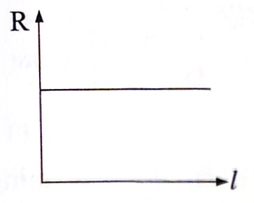

1. 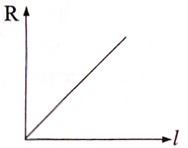 **B.**

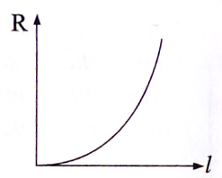

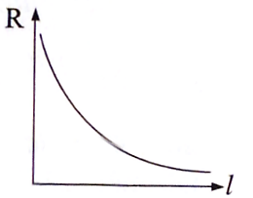 **C**. **D.**

1. Diagram 26 shows four identical bulbs connected to a cell of 6V.

Which bulb, **A, B, C** or **D** is the brightest?

*Rajah* 26 *menunjukkan empat mentol serupa yang disambungkan kepada sebuah sel* 6V*.   
Mentol yang manakah* **A, B, C** *atau* **D** *akan menyala paling cerah?*

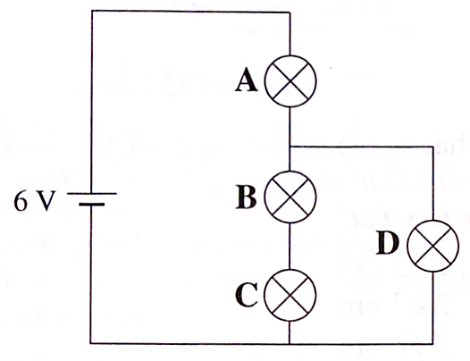

Diagram 26

*Rajah* 26

1. Diagram 27 shows an electric circuit consisting of a battery with *e.m.f* 1.5 V and internal

resistance 0.5 Ω is connected to a resistor 2 Ω.

*Rajah* 27 *menunjukkan satu litar elektrik yang mengandungi satu bateri dengan d.g.e* 1.5V *dan rintangan dalam* 0.5 Ω *disambung kepada sebuah perintang* 2 Ω*.*

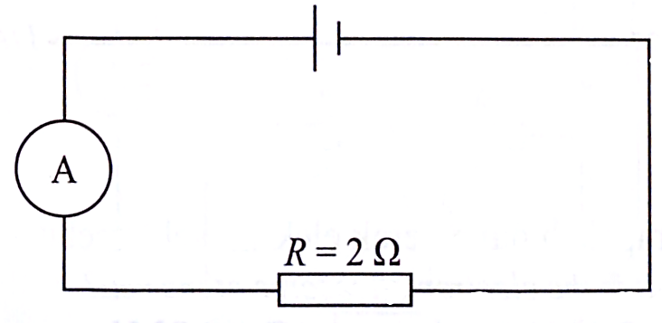

Diagram 27

*Rajah* 27

What is the ammeter reading when the switch is on?

*Berapakah bacaan ammeter apabila suis dihidupkan?*

**A** 0.3 A

**B** 0.5 A

**C** 0.6 A

**D** 0.8 A

1. An electric heater of resistance 60Ω connected to 240V is working normally.

How long would it take for the heater to transform 360 kJ of electrical energy?

*Sebuah pemanas elektrik dengan rintangan* 60Ω *disambungkan ke bekalan kuasa* 240V *dapat berfungsi secara normal. Berapa lamakah masa yang diambil oleh pemanas itu untuk menukarkan* 360 kJ *tenaga elektrik?*

**A** 25 s

**B** 40 s

**C** 375 s

**D** 90 000 s

1. Diagram 28 shows the apparatus set-up to observe the magnetic field produced by two long and

straight current-carrying conductors.

*Rajah* 28 *menunjukkan susunan radas untuk memerhatikan medan magnet yang dihasilkan oleh dua konduktor pembawa arus yang panjang dan lurus.*

Conductor

Konduktor

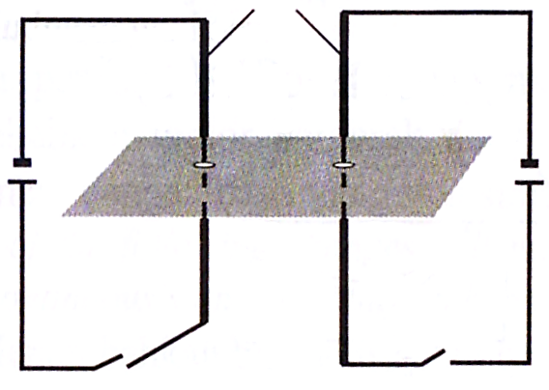

Diagram 28

*Rajah* 28

Which diagram shows the magnetic field **correctly**?

*Rajah manakah menunjukkan medan magnet yang* ***betul****?*

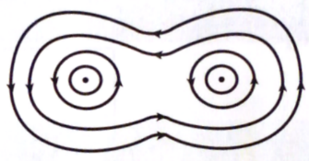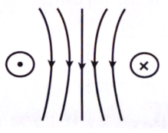

**A C**

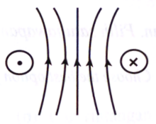

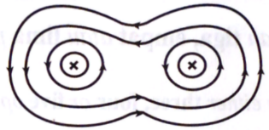**B D**

1. Diagram 29 shows a wire hanging freely between the poles of a magnet.

*Rajah* 29 *menunjukkan satu wayar digantung bebas di antara dua kutub sebuah magnet.*

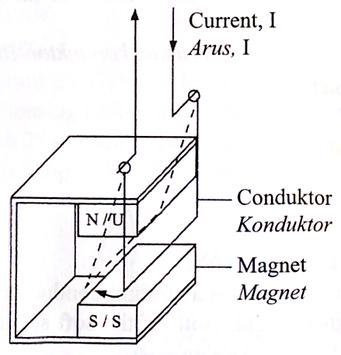

Diagram 29

*Rajah* 29

The speed of deflection of the wire can be increased by

*Halaju pesongan wayar boleh bertambah dengan*

**A** Changing the polarity of the power supply

Mengubah kepolaran bekalan kuasa

**B** Increasing the current

Meningkatkan arus

**C** Using thinner piece of wire

Menggunakan wayar yang nipis

**D** Using constantan wire

Menggunakan wayar konstantan

1. Diagram 30 shows a solenoid and a bar magnet.

*Rajah* 30 *menunjukkan satu solenoid dan satu magnet bar.*

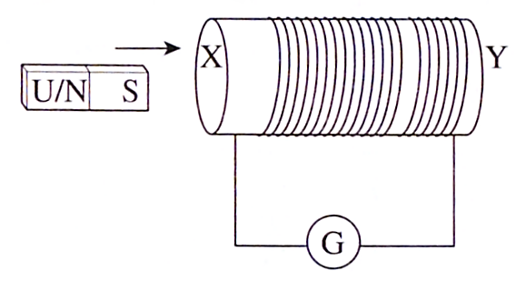

Diagram 30

*Rajah* 30

What happens when the bar magnet is pushed into the solenoid?

*Apakah yang berlaku apabila magnet bar ditolak ke dalam solenoid?*

1. Kinetic energy changes to heat energy

Tenaga kinetik ditukarkan kepada tenaga haba

1. Pole X becomes the South pole

Kutub X menjadi kutub Selatan

1. An induced current flow through the galvanometer

Arus aruhan mengalir melalui galvanometer

1. No deflection is seen on the galvanometer

Tiada pesongan dilihat pada galvanometer

1. Diagram 31 shows the structure of a transformer.

*Rajah* 3*1 menunjukkan struktur sebuah transformer.*

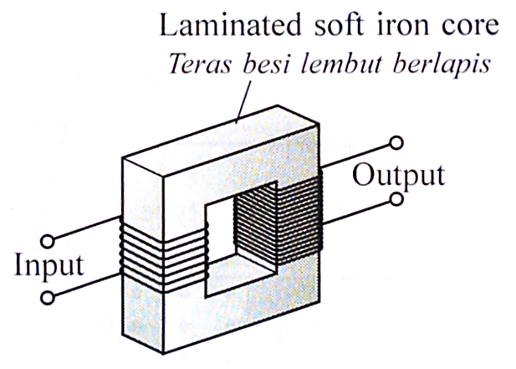

Diagram 31

*Rajah* 31

What is the function of laminated soft iron core?

*Apakah fungsi bagi teras besi lembut berlamina?*

**A** To reduce eddy current

Untuk mengurangkan arus pusar

**B** To increase eddy current

Untuk meningkatkan arus pusar

**C** To prevent flux leakage

Untuk mencegah kebocoran fluks

**D** To cool down the transformer

Untuk menyejukkan transformer

1. Diagram 32 shows the National Grid Network in Malaysia.

*Rajah* 32 *menunjukkan Rangkaian Grid Nasional di Malaysia.*

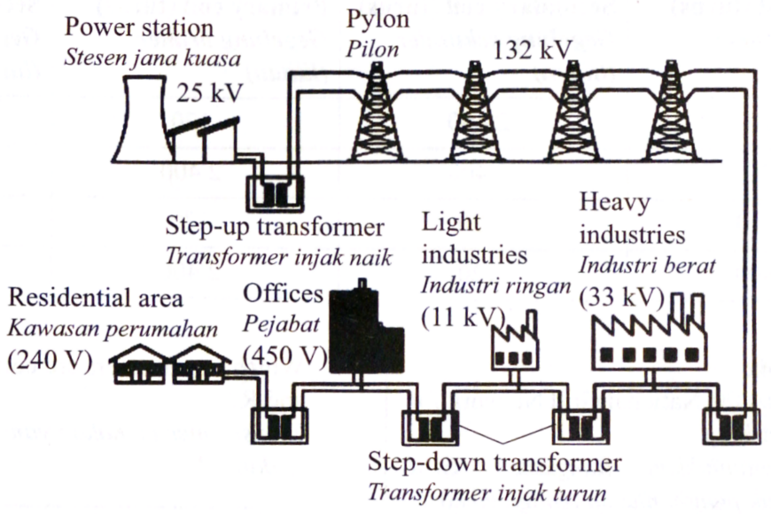

Diagram 32

*Rajah* 32

Which of the following is a disadvantage of this type of network?

*Antara yang berikut yang manakah kelemahan rangkaian jenis ini?*

1. Smaller and less efficient stations can be closed down during off-peak period

Stesen yang kecil dan kurang efisien boleh ditutup ketika bukan masa puncak

1. Repairs and maintenance can be carried out at any station at any time

Pembaikan dan penyelenggaraan boleh dilakukan di mana-mana stesen pada bila-bila masa

1. Lost of generation of electricity is high because power loss increases in cables

Kehilangan penjanaan elektrik tinggi kerana kehilangan kuasa bertambah dalam kabel

1. Power stations can be located outside the city area

Stesen janakuasa boleh ditempatkan di luar kawasan bandar

1. Diagram 33 shows the output waveform on a cathode ray oscilloscope (CRO) screen.

*Rajah* 33 *menunjukkan bentuk gelombang output pada skrin osiloskop sinar katod (OSK).*

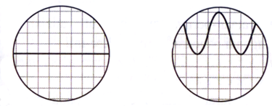

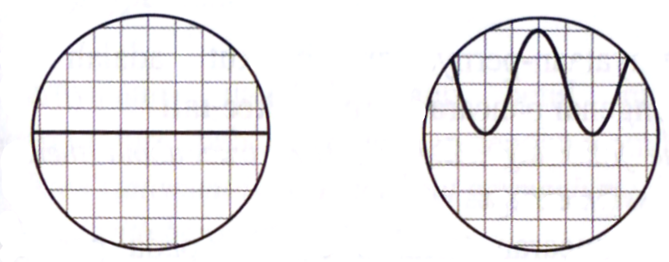

When switch is on

Apabila suis dihidupkan

When switch is off

Apabila suis dimatikan

Diagram 33

*Rajah* 33

Which circuit will display the output waveform shown in Diagram 33?

*Litar yang manakah akan memaparkan bentuk gelombang output dalam Rajah* 33*?*

1. 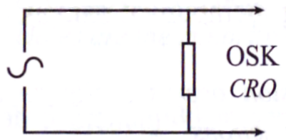.

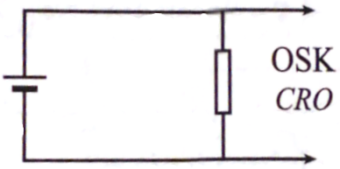

1. .

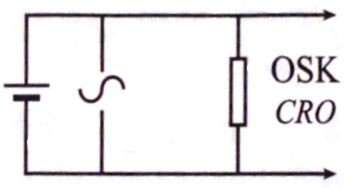

1. .

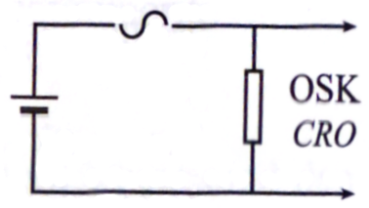

**D**

1. Diagram 34 shows the connection of four diodes and one light bulb in a circuit.

*Rajah* 34 *menunjukkan sambungan empat diod dan satu mentol dalam satu litar.*

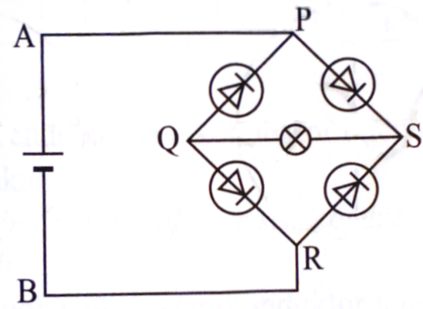

Diagram 34

*Rajah* 34

Which direction of the current flow in the circuit will light up the bulb?

*Arah arus yang manakah mengalir dalam litar akan menyalakan mentol itu?*

1. APSQRB
2. APQSRB
3. BRSQPA
4. BRQSPA
5. Diagram 35 shows an automatic switch circuit.

*Rajah* 35 *menunjukkan satu litar suis automatik.*

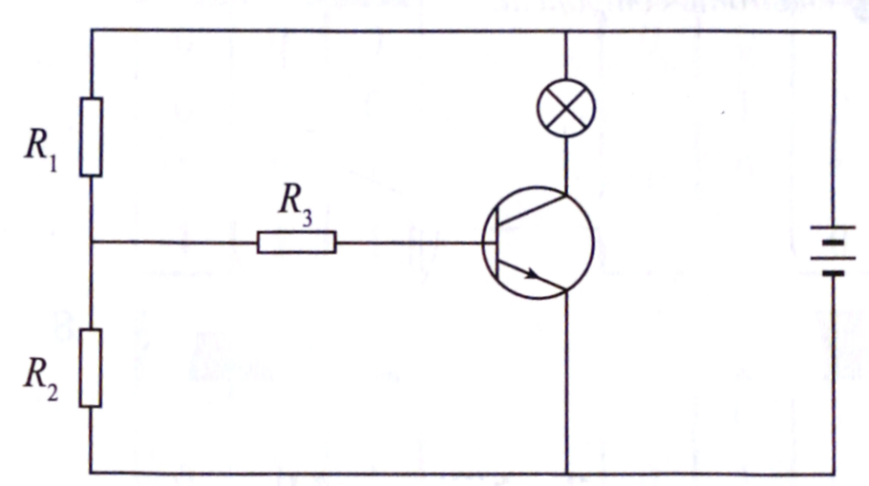

Diagram 35

*Rajah* 35

Which statement is **true**?

*Pernyataan yang manakah* ***benar****?*

1. If R1 is a light dependent resistor, the bulb lights up during the day time

Jika R1 ialah perintang peka cahaya, mentol menyala pada waktu siang

1. If R2 is a light dependent resistor, the bulb lights up during the day time

Jika R2 ialah perintang peka cahaya, mentol menyala pada waktu siang

1. If R3 is a light dependent resistor, the bulb lights up during the day time

Jika R3 ialah perintang peka cahaya, mentol menyala pada waktu siang

1. If the terminals of the battery are reversed, the bulb lights up during the day time

Jika terminal bateri disongsangkan, mentol menyala pada waktu siang

1. Which of the following logic gate will produce output signals of 1000?

*Antara get logik berikut yang manakah menghasilkan isyarat output* 1000*?*

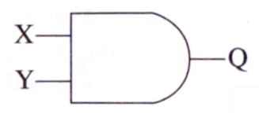

1. .

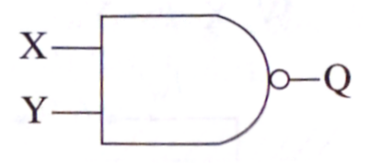

1. .

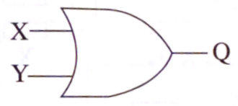

1. .

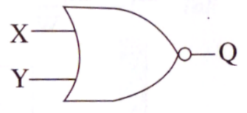

1. .

202

80

X

1. What are the particles inside the nucleus of ?

202

80

X

*Apakah zarah-zarah yang terdapat dalam nuklues*  ?

1. 80 electrons and 122 protons

80 elektron dan 122 proton

1. 80 electrons and 122 neutrons

80 elektron dan 122 neutron

1. 80 electrons and 202 neutrons

80 elektron dan 202 neutron

1. 122 protons and 202 neutrons

122 proton dan 202 neutron

1. Diagram 36 shows a decay curve for a radioactive substance.

*Rajah* 36 *menunjukkan satu lengkung reputan bagi suatu bahan radioaktif.*

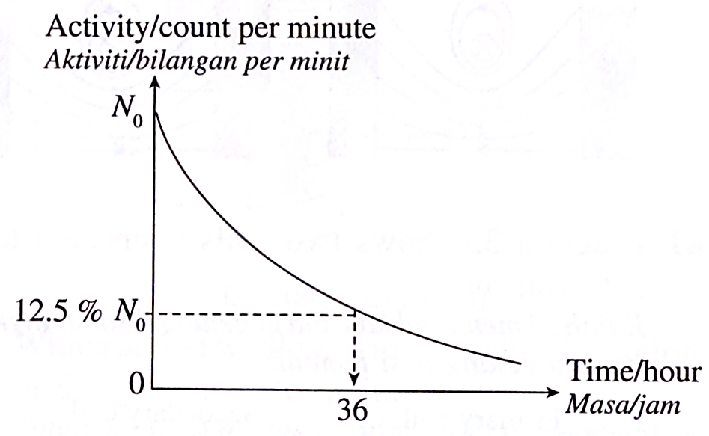

Diagram 36

*Rajah* 36

What is the half-life of the radioactive substance?

*Berapakah separuh hayat bagi bahan radioaktif tersebut?*

1. 9 hours

9 jam

1. 12 hours

12 jam

1. 18 hours

18 jam

1. 72 hours

72 jam

1. Table 1 shows the half-life of four types of liquid isotopes which radiates gamma ray.

*Jadual* 1 *menunjukkan separuh hayat bagi empat jenis cecair isotop yang memancarkan*

*sinaran gama.*

|  |  |
| --- | --- |
| Isotope  *Isotop* | Half-life  *Separuh hayat* |
| P | 10 seconds  10 *saat* |
| Q | 2 hours  2 *jam* |
| R | 5 months  5 *bulan* |
| S | 10 years  10 *tahun* |

Table 1

*Jadual* 1

Which liquids isotopes is suitable to detect blood clotting?

*Isotop cecair manakah sesuai digunakan untuk mengesan pembekuan darah?*

1. P
2. Q
3. R
4. S
5. A nuclear reactor produces 315 000 J of heat in a nuclear reaction.

What is the mass defect in the nuclear reaction?

*Sebuah reaktor nuklear menghasilkan* 315 000 J *haba dalam suatu tindak balas nuklear.   
 Berapakah cacat jisim dalam tindak balas nuklear itu?*

1. 3.5 x 10 -12 kg
2. 1.05 x 10 -3 kg
3. 3.5 x 10 4 kg
4. 1.05 x 10 5 kg

**END OF QUESTION PAPER**

***KERTAS PEPERIKSAAN TAMAT***